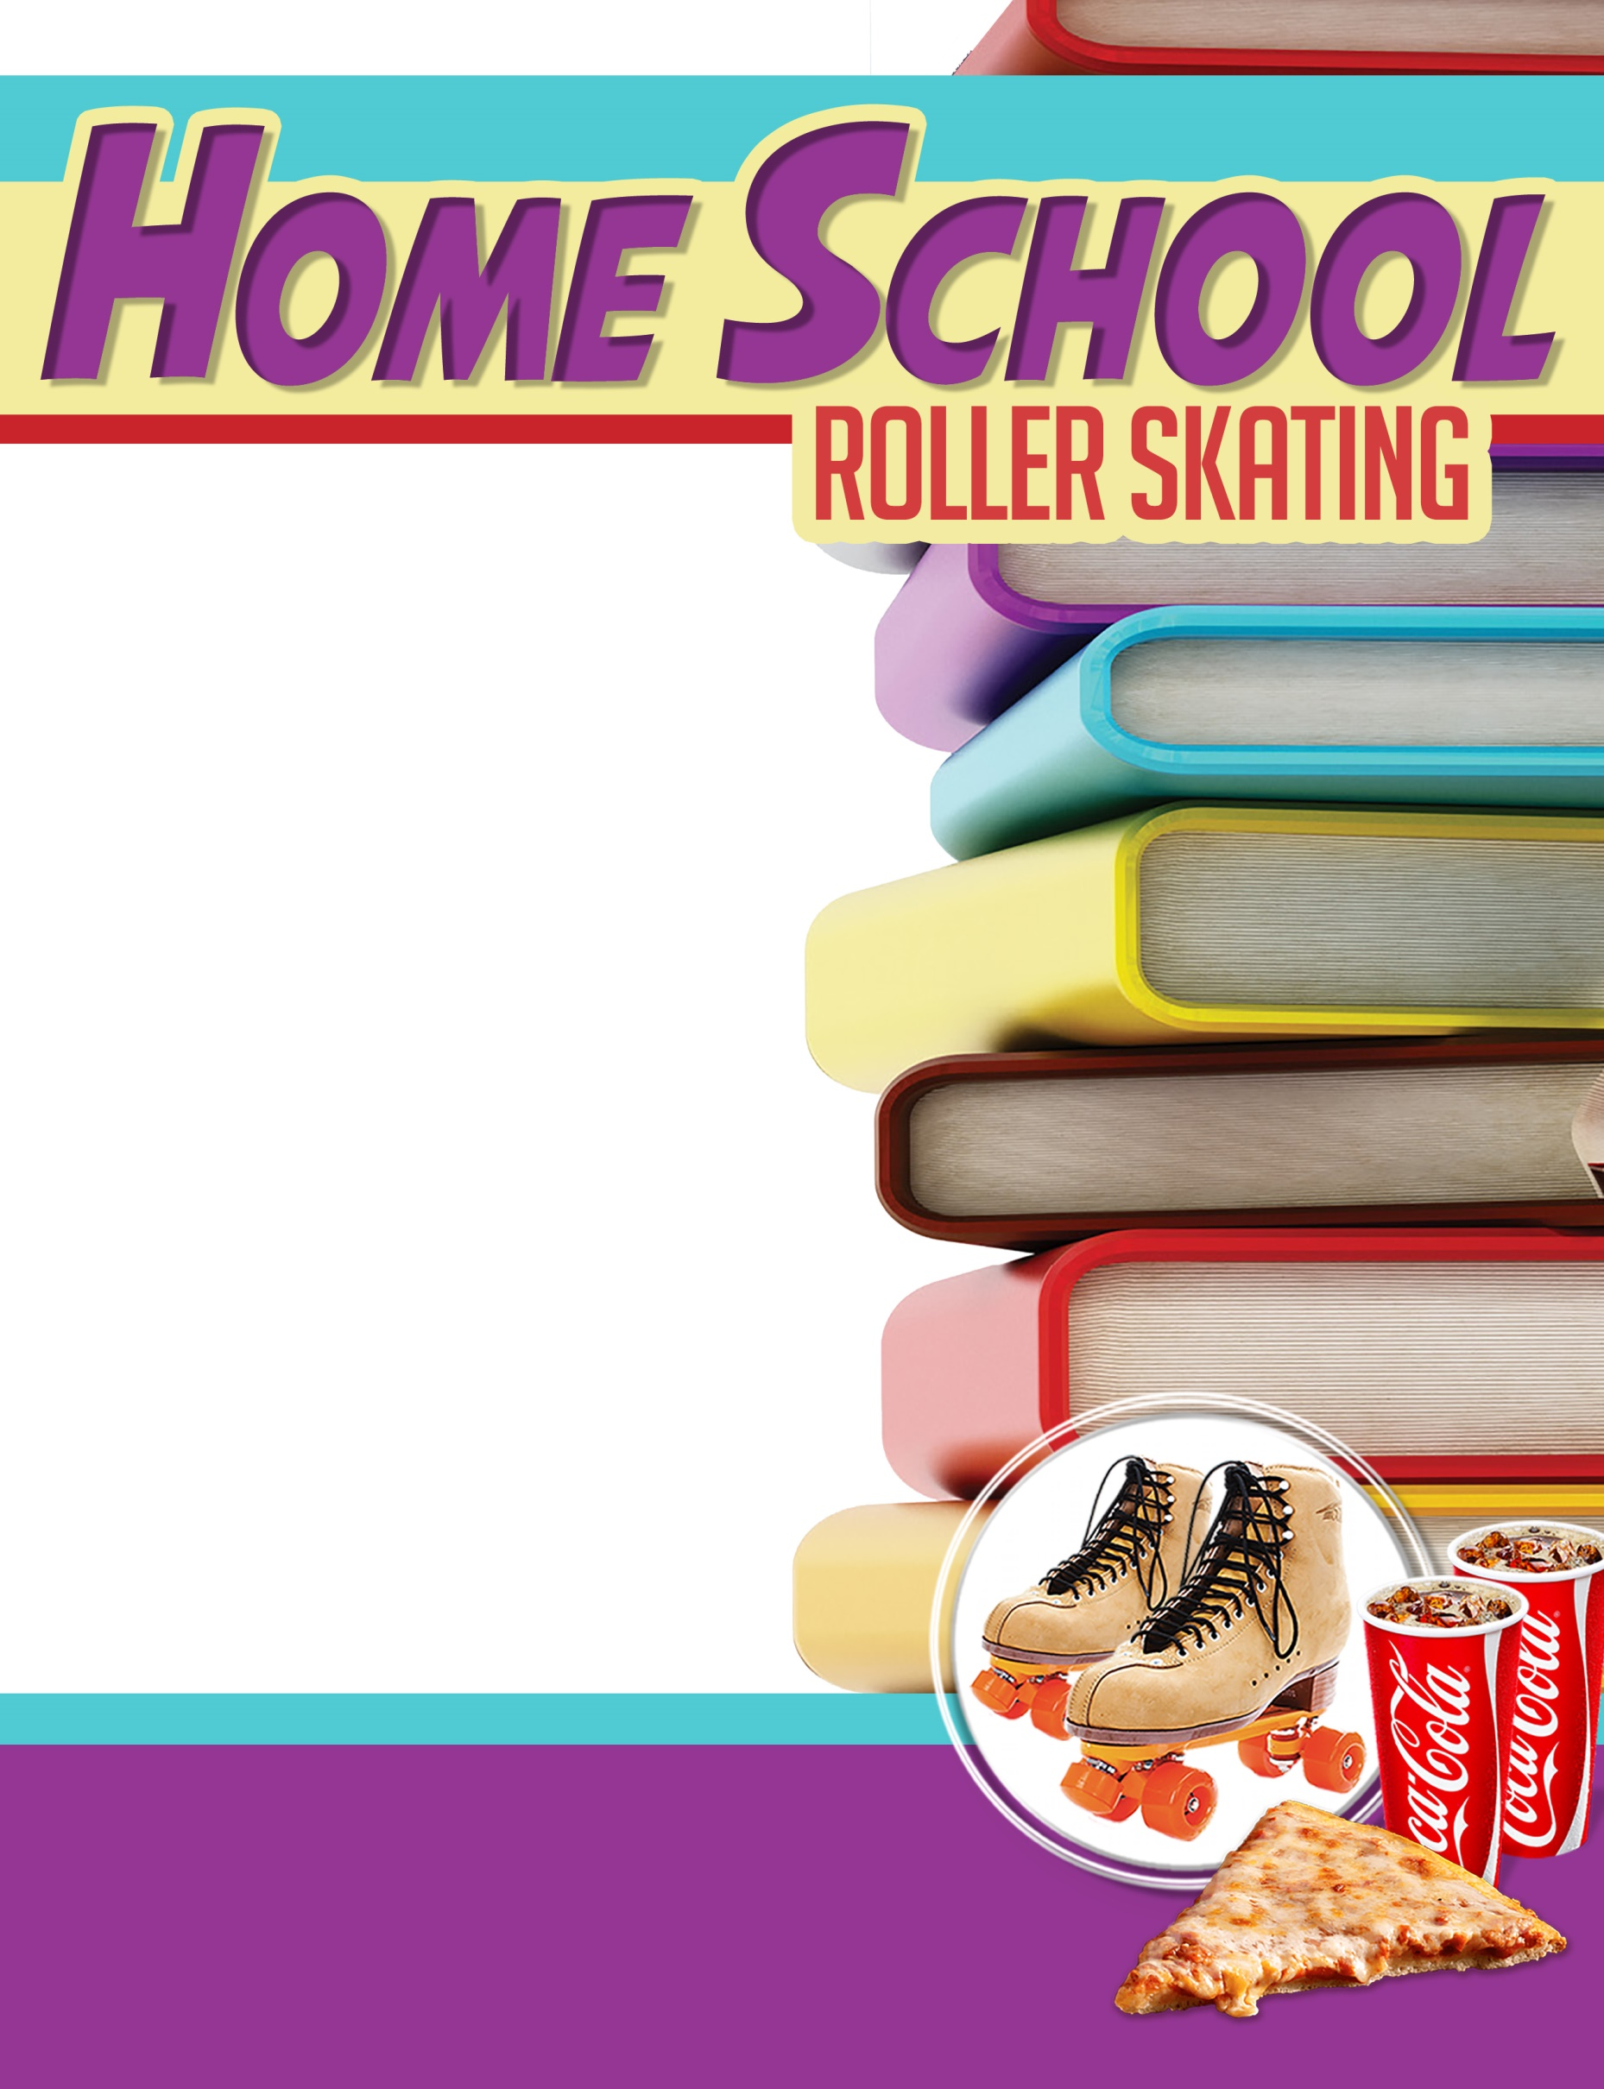
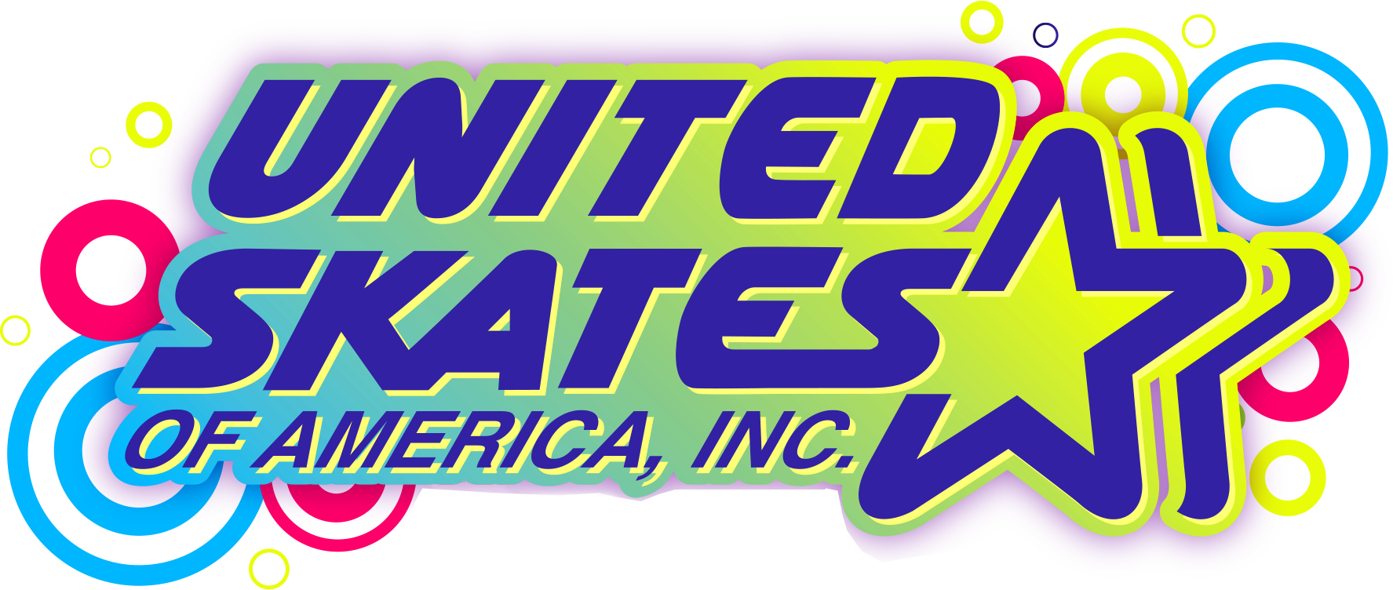

The Best Christian
Pop Music Mix
$9.50 admission
(includes STEM Lesson & Skate Rental)

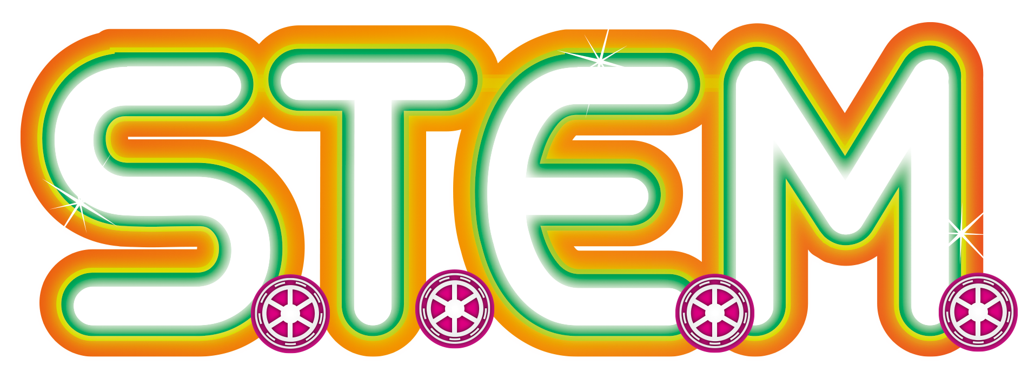

1st Fridays of Every Month
1:00pm to 3:00pm

DATES:
June 7th, 2024
July 4th, 2024
June 7th, 2024
July 4th, 2024
June 7th, 2024
July 4th, 2024
DATES:
June 7th, 2024
July 4th, 2024
June 7th, 2024
July 4th, 2024
June 7th, 2024
July 4th, 2024
Exclusively For Home Schools!
Welcome Back! Now Grab Your Friends!
1276 Hicksville Road Seaford, NY 11783 • (516) 795-5474
www.UnitedSkates.com/Seaford

